

**OpsLogix Instruction for CreateNewMP**

Arvato Finance

Date: 2020-09-10  
Version: 1

Table of Contents

Introduction 2

Summary 2

Change log 2

Overview 3

To use the scripts 4

CreateOverrideMP 4

CreateMonitoringMP 5

# Introduction

## Summary

This document provides instructions on how to use CreateNewMP scripts to create overrides and monitor MPs

## Change log

|  |  |  |  |
| --- | --- | --- | --- |
| **Version** | **Date** | **Changed by** | **Changes** |
| 1 | 2020-09-10 | Rickard Nygren | Original version |
|  |  |  |  |

# Overview

This document describe how to use the two CreateNewMP scripts.

* CreateOverrideMP.ps1

*To use when you want to create MPs that you want to save overrides in.*

* CreateMonitoringMP.ps1

*To use when you want to create MPs that you want to save new created monitors or rules in.*

# To use the scripts

## CreateOverrideMP

The Operations Console can be used to create new Management Packs but this is not a recommended method because the Console will add unnecessary data (views and language information) to the Management Pack which will clutter up the SCOM environment. Instead, always use a template when creating a new Management Pack.

* To create the Override Management Pack we run one script:
  1. Log on to the SCOM server or some other server where you have saved the script.
  2. Go to the folder **C:\install\SCOM\Supported\MPs\CreateNewMP\**
  3. Start one **Windows** **Powershell** windows
  4. Run the script **CreateOverrideMP.ps1**
  5. Follow the information in the screen
     + **Name** – Provide the name of the Override Management Pack in the form ***'Manufacturer Product Version'***. For example ***Microsoft Windows Server IIS 2012***. The script will add **_** and **– Overrides**
     + **Continue** – if you want to go further choose ***Y***
     + **Import** – if you want to import the MP into the SCOM group then choose ***Y***, otherwise the MP will be saved in the same folders as you run the script.

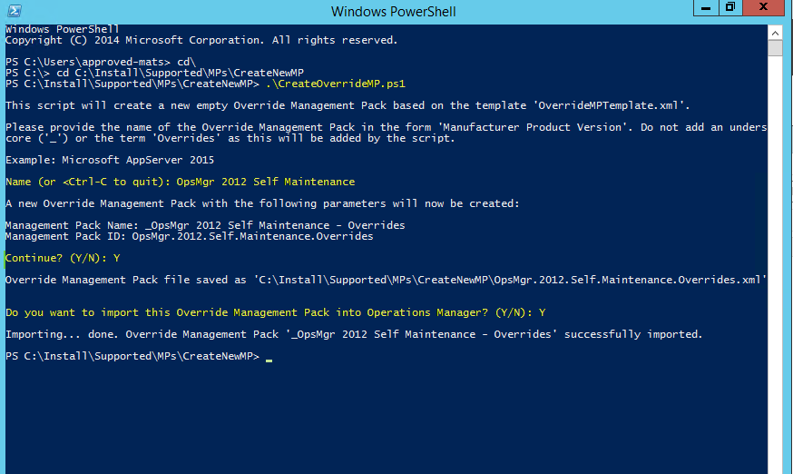

## CreateMonitoringMP

* To create the Override Management Pack we run one script:
  1. Log on to the SCOM server or some other server where you have saved the script.
  2. Go to the folder **C:\install\SCOM\Supported\MPs\CreateNewMP\**
  3. Start one **Windows** **Powershell** windows
  4. Run the script **CreateMonitoringMP.ps1**
  5. Follow the information in the screen
     + **Name** – the name of the new MP. For example **Approved Personec 1.0**
     + **Continue** – if you want to go further choose ***Y***
     + **Import** – if you want to import the MP into the SCOM group then choose ***Y***, otherwise the MP will be saved in the same folders as you run the script.

